
The Global Consciousness Project
Roger D. Nelson, Director
http://noosphere.princeton.edu
rdnelson@princeton.edu (609) 924 4875

July 31, 2026

John R. Colgan
Jones Day
77 W. Wacker
Chicago, IL 60601-1692

Dear John,

Following is the accounting for my consulting time during August 2007.

August 8 working lunch and meeting, John Colgan, John Marlott, Richard Birnholz.
Show REG devices and documentation, explain technology. 12:00 to 5:45 5.75 hrs

August 16 conf call John Colgan, Richard Birnholz 0.50 hr

August 18 John Bradish research 0.25 hr

August 19 John Bradish telephone, email to Colgan 0.50 hr

August, misc calls and emails, minutes 5 5 5 5 10 0.50 hr

Total 7.50 hrs

Sincerely yours,
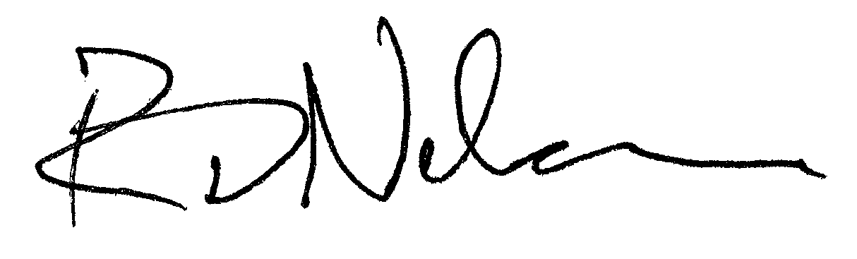

Roger D. Nelson
196 Valley Road, Princeton, NJ 08540, 609-924-4875

